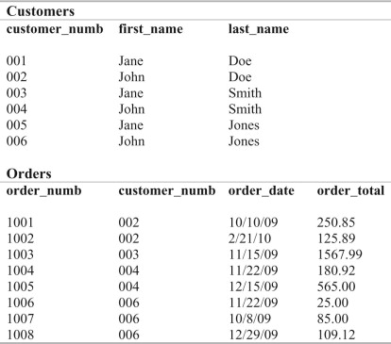

**Q1. Write a query for displaying customer customer name in upper case as “Customer Name”.**

SELECT CONCAT(UPPER(LEFT(first_name, 1)), LOWER(SUBSTRING(first_name, 2)), ' ', LOWER(SUBSTRING(last_name, 1))) AS Customer_Name FROM customers;

**Q2. Write a query for displaying first and last order.**

Select max(order_date) as “last order”, min(order_date) as “first order” from orders;

**Q3. Display the average of the order_total.**

Select avg(order_total) from orders;

**Q4. Modify the above query and calculate order_total by grouping them according to the customer_numb.**

Select avg(order_total) from orders group by customer_numb;

**Q5. Write a query to display the position of “a” alphabet in customer name.**

SELECT name, INSTR(name, 'a') AS a_position FROM customers;